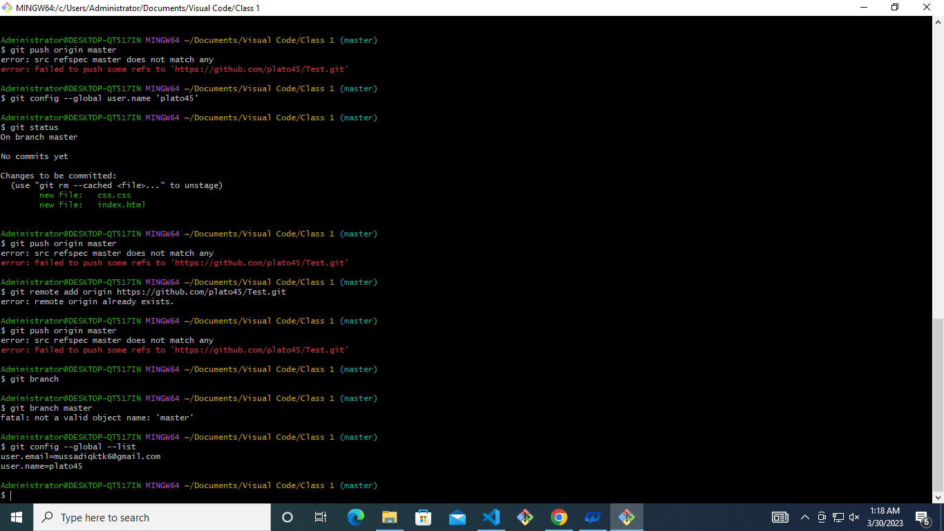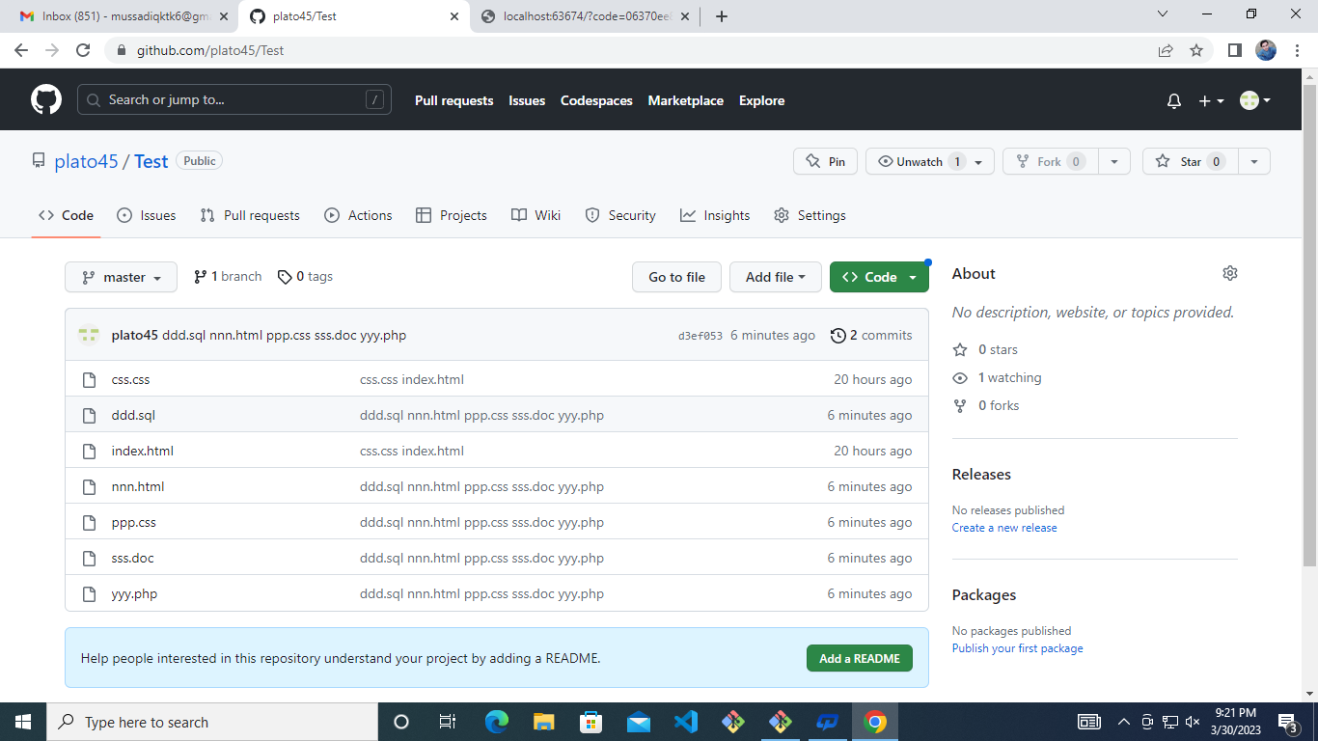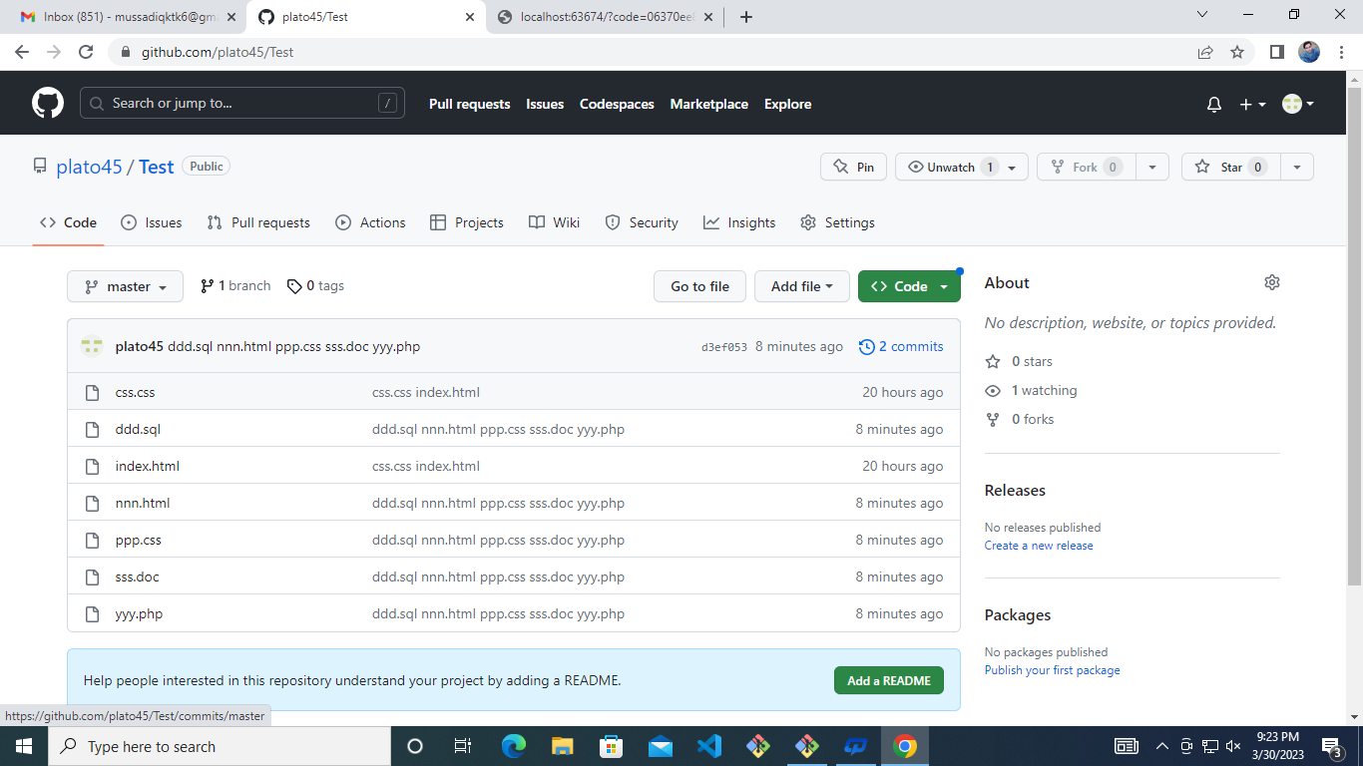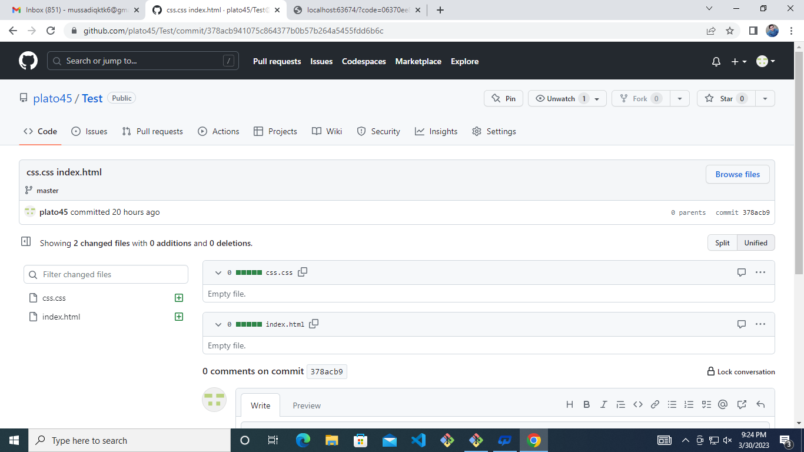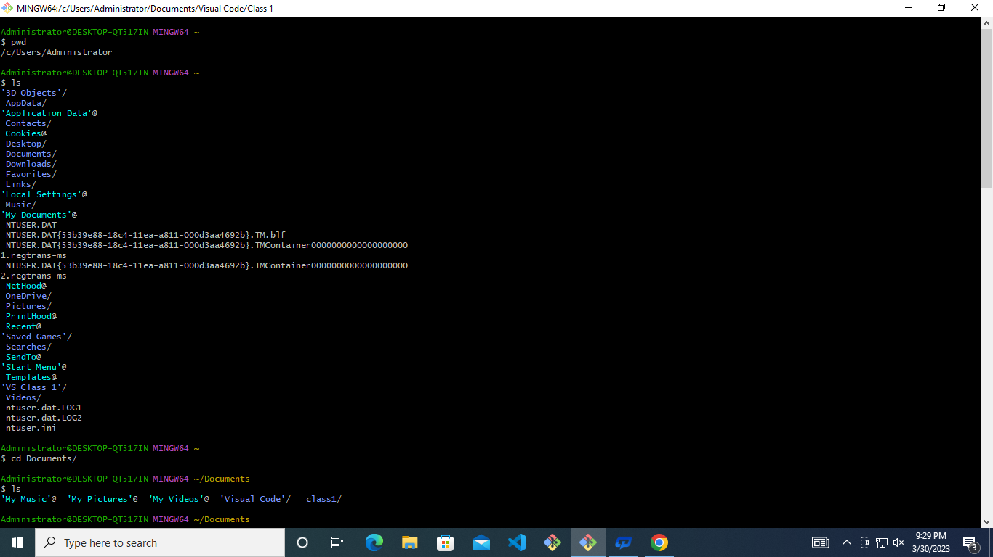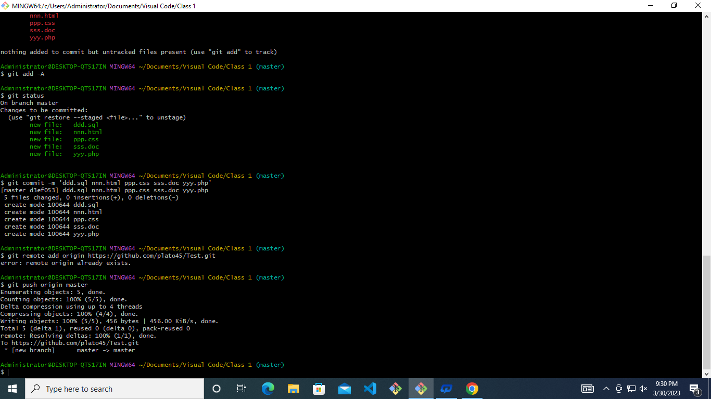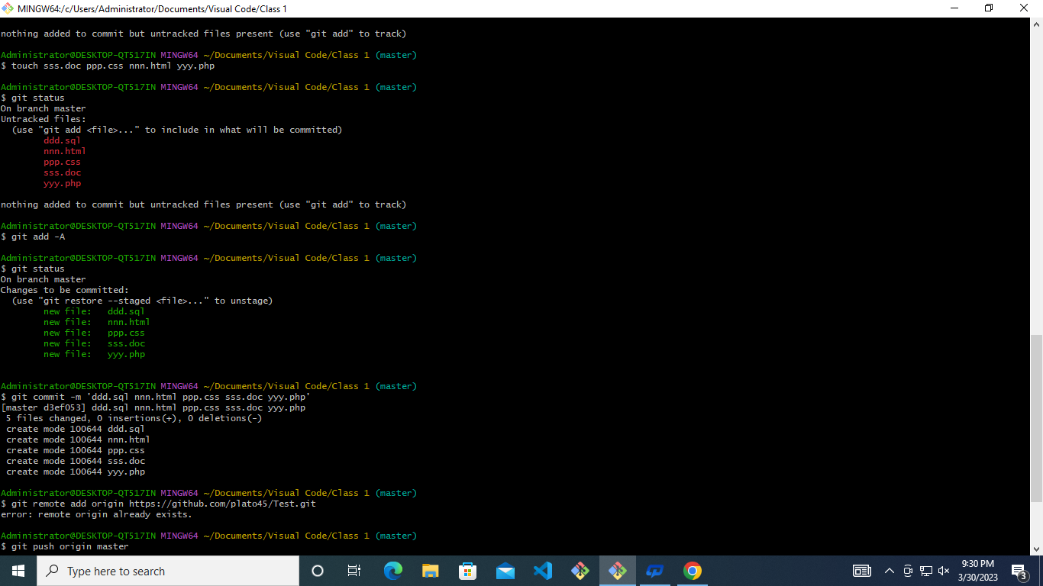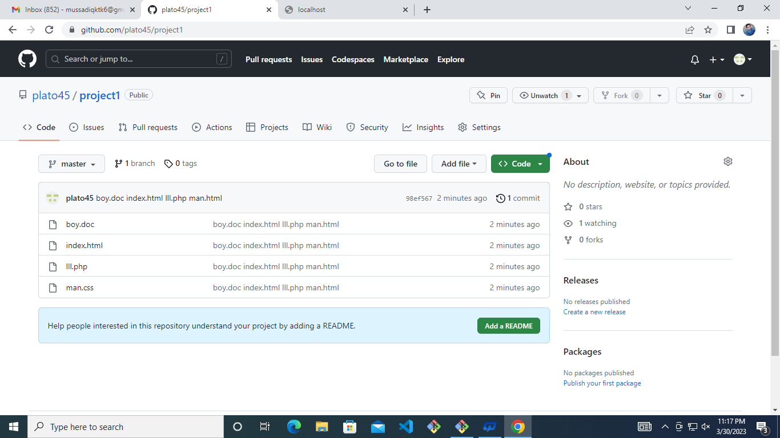

Administrator@DESKTOP-QT517IN MINGW64 ~

$ pwd

/c/Users/Administrator

Administrator@DESKTOP-QT517IN MINGW64 ~

$ ls

'3D Objects'/ Documents/ Music/ NetHood@ Searches/ ntuser.dat.LOG1

AppData/ Downloads/ 'My Documents'@ OneDrive/ SendTo@ ntuser.dat.LOG2

'Application Data'@ Favorites/ NTUSER.DAT Pictures/ 'Start Menu'@ ntuser.ini

Contacts/ IntelGraphicsProfiles/ NTUSER.DAT{53b39e88-18c4-11ea-a811-000d3aa4692b}.TM.blf PrintHood@ Templates@

Cookies@ Links/ NTUSER.DAT{53b39e88-18c4-11ea-a811-000d3aa4692b}.TMContainer00000000000000000001.regtrans-ms Recent@ 'VS Class 1'/

Desktop/ 'Local Settings'@ NTUSER.DAT{53b39e88-18c4-11ea-a811-000d3aa4692b}.TMContainer00000000000000000002.regtrans-ms 'Saved Games'/ Videos/

Administrator@DESKTOP-QT517IN MINGW64 ~

$ cd Documents/

Administrator@DESKTOP-QT517IN MINGW64 ~/Documents

$ ls

'My Music'@ 'My Pictures'@ 'My Videos'@ 'Visual Code'/ class1/

Administrator@DESKTOP-QT517IN MINGW64 ~/Documents

$ cd class1/

Administrator@DESKTOP-QT517IN MINGW64 ~/Documents/class1 (master)

$ ls

allied.html amir/ country.xl farid/ html/ html.css java/ mussadiq/ mussadiq.dom store.doc

Administrator@DESKTOP-QT517IN MINGW64 ~/Documents/class1 (master)

$ mkdir project

Administrator@DESKTOP-QT517IN MINGW64 ~/Documents/class1 (master)

$ ls

allied.html amir/ country.xl farid/ html/ html.css java/ mussadiq/ mussadiq.dom project/ store.doc

Administrator@DESKTOP-QT517IN MINGW64 ~/Documents/class1 (master)

$ cd project/

Administrator@DESKTOP-QT517IN MINGW64 ~/Documents/class1/project (master)

$ touch man.css boy.doc index.html lll.php

Administrator@DESKTOP-QT517IN MINGW64 ~/Documents/class1/project (master)

$ ls

boy.doc index.html lll.php man.css

Administrator@DESKTOP-QT517IN MINGW64 ~/Documents/class1/project (master)

$ git config --global --list

user.email=mussadiqktk6@gmail.com

user.name=plato45

Administrator@DESKTOP-QT517IN MINGW64 ~/Documents/class1/project (master)

$ git status

On branch master

No commits yet

Untracked files:

(use "git add <file>..." to include in what will be committed)

../allied.html

../country.xl

../html.css

../mussadiq.dom

./

../store.doc

nothing added to commit but untracked files present (use "git add" to track)

Administrator@DESKTOP-QT517IN MINGW64 ~/Documents/class1/project (master)

$ git init

Initialized empty Git repository in C:/Users/Administrator/Documents/class1/project/.git/

Administrator@DESKTOP-QT517IN MINGW64 ~/Documents/class1/project (master)

$ git status

On branch master

No commits yet

Untracked files:

(use "git add <file>..." to include in what will be committed)

boy.doc

index.html

lll.php

man.css

nothing added to commit but untracked files present (use "git add" to track)

Administrator@DESKTOP-QT517IN MINGW64 ~/Documents/class1/project (master)

$ git commit -m

error: switch `m' requires a value

Administrator@DESKTOP-QT517IN MINGW64 ~/Documents/class1/project (master)

$ git commit -m 'by.doc index.html lll.php man.css'

On branch master

Initial commit

Untracked files:

(use "git add <file>..." to include in what will be committed)

boy.doc

index.html

lll.php

man.css

nothing added to commit but untracked files present (use "git add" to track)

Administrator@DESKTOP-QT517IN MINGW64 ~/Documents/class1/project (master)

$ git add -A

Administrator@DESKTOP-QT517IN MINGW64 ~/Documents/class1/project (master)

$ git status

On branch master

No commits yet

Changes to be committed:

(use "git rm --cached <file>..." to unstage)

new file: boy.doc

new file: index.html

new file: lll.php

new file: man.css

Administrator@DESKTOP-QT517IN MINGW64 ~/Documents/class1/project (master)

$ git commit -m 'boy.doc index.html lll.php man.html'

[master (root-commit) 98ef567] boy.doc index.html lll.php man.html

4 files changed, 0 insertions(+), 0 deletions(-)

create mode 100644 boy.doc

create mode 100644 index.html

create mode 100644 lll.php

create mode 100644 man.css

Administrator@DESKTOP-QT517IN MINGW64 ~/Documents/class1/project (master)

$ git remote add origin https://github.com/plato45/project1.git

Administrator@DESKTOP-QT517IN MINGW64 ~/Documents/class1/project (master)

$ git push origin master

Enumerating objects: 3, done.

Counting objects: 100% (3/3), done.

Delta compression using up to 4 threads

Compressing objects: 100% (2/2), done.

Writing objects: 100% (3/3), 260 bytes | 260.00 KiB/s, done.

Total 3 (delta 0), reused 0 (delta 0), pack-reused 0

To https://github.com/plato45/project1.git

\* [new branch] master -> master

Administrator@DESKTOP-QT517IN MINGW64 ~/Documents/class1/project (master)

$ ^C

Administrator@DESKTOP-QT517IN MINGW64 ~/Documents/class1/project (master)

$ '/c/Users/Administrator/Desktop/Mussadiq Farid/Mussadiq github assignment.odt'